Download pandas json :

https://ai-process-sandy.s3.eu-west-1.amazonaws.com/purge/deviation.json Context:

These are deviations of floor vs ceiling corners of one of our models with ground truth labels for the room name and number of corners in that room with predictions. Please create meaningful statistics of how well the model performed.

Gt_corners = ground truth number of corners in the room

Rb_corners = number of corners found by the model

Mean max min and all others are deviation values in degrees.

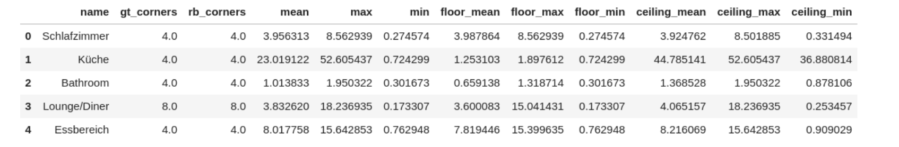Create project in idea, pycharm or vscode

Create requirements.txt and virtual env

Create class for drawing plots

Create function “draw_plots”

→ reads json file passed as parameter as a pandas dataframe

→ draws plot for comparing different columns

→ saves plots in a folder called “plots”

→ returns paths to all plots

Create jupyter notebook called Notebook.ipynb in the root directory to call and visualize our plots

Publish the project on github and attach a link to the repository in your cover letter or paste it in the "replies" line

P.S. if something is not clear do not hesitate to ask